 | Nancy Willis, Certified Pedorthist  Mobile Service: Kingston, ON  613.545.2367 or 866.683.8260  ceo.nancy.willis@gmail.com

SHOE SUPPORT EVALUATION 101

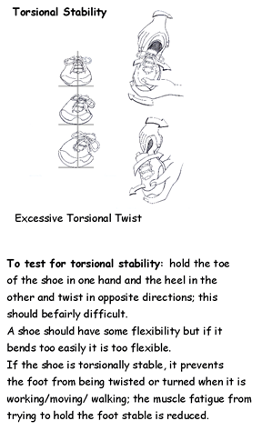 | 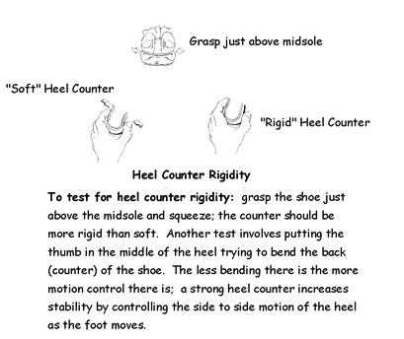
 | 